**CONTENT**

Project work task 3

Work annotation 5

Introduction 6

1. **System Architecture –Description Section** 7
   1. Sequence Diagram 9
   2. Activity Diagram 10
2. **System Analysis – Technological Section** 10
   1. System Analysis – Existing System: 11
   2. System Analysis – Proposed System 12
   3. System Analysis – Feasibility Analysis 13
3. **Work Organization Section** 14

Conclussions and recommendations 15

List of used literature and other resources 16

**Work Annotation**

**1 - Purpose:**

The purpose of the Student Information System is to allow any administrator.

This software is built to help the organization organize and find a student's personal details, keep the student's profile up to date. It will also make it easier to keep all records of students. Their IDs, names, addresses, phone numbers, average grades, etc.

Results and records about a student will be available in a few seconds.

Overall, it will make Student Information Management an easier job for the administrator.

The main purpose of this Student Information Report is to demonstrate the requirements of the project.

It is intended to maintain and assist the Student Information System and any organization and manages the student's personal data.

**2 - Scope:**

Without a Student Information System, managing and maintaining details is a tedious task for any organization.

The Student Information system will store all the information of the students including their own information (personal details and information about all their resumes.)

**Introduction**

Student Management System is software written to assist school authorities in the registration process. In the current system, all operations are done manually. It is very time consuming and costly. With this software, operations become easier.

Student Information Management System can be used by education institutes to maintain the

records of students easily. Achieving this objective is difficult using a manual system as the

information is scattered, can be redundant and collecting relevant information may be very time

consuming. All these problems are solved using this project.

My Student Management System takes care of the registration and updating of students. It prevents confusion and makes it easier to reach the student. Thanks to the student's contact number and address section, necessary documents can be sent to the student's home as well as making it possible to reach the student by calling.

We cannot register as users in the software. It only gives 1 admin permission for now. However, with minor updates, new administrator accounts can be added and logs can be kept about the transactions.

The administrator has the authority to add new students and can edit and delete a user. All students can access their data in a single list. And the changes are not deleted when the application is closed.

* + - 1. **System Architecture**

**Overall Description**

* *Product Perspective :*

The Student Information Management System is aimed towards recording a

considerable number of student records and needs assistance for managing

records of students.

Student Information System is intended to be a stand-alone product and should

not depend on the availability of other website. The system will also have an

administrator who has full-fledged rights with regards to performing all actions

related to control and management of the website.

*The features that are available to the Administrator are:*

* An Administrator can login into the system and perform any of the available operations.
* Can enable/disable student.
* Can edit student information to the file.
* Can make search for a specific student.
* Can access all the details of the student.

User Classes and Characteristics :

The users include:

* Administrator

Operating Environment :

* The product can run on any computer.

Constraints :

* Every user must be comfortable using computer.
* All operations are in English so user must have basic knowledge of English.

**Code Descriptions**

* **Variables**

int i,j;  
int main_exit;  
int createAccount_exit;  
void menu();

* **Functions**

void createAccount(); //Function to create student accounts  
void displayInfo(); //Function to display student informations  
void updateInfo(); //Function to update student information  
void deleteInfo(); //Function to delete student information  
void searchInfo(); //Function for search student information

* **Main Menu Functions**

void menu()  
{  
 char option;  
  
 while (option != '0')  
 {system("cls");  
 printf("\n\n\t\t\t\xB2\xB2\xB2\xB2\xB2\xB2\xB2 STUDENT DATABASE SYSTEM \xB2\xB2\xB2\xB2\xB2\xB2\xB2");  
 printf("\n\t\t\t1. Create Student Account");  
 printf("\n\t\t\t2. Display All Students Information");  
 printf("\n\t\t\t3. Update Student Information");  
 printf("\n\t\t\t4. Delete Student Information");  
 printf("\n\t\t\t5. Search Student Information");  
 printf("\n\t\t\t0. Exit");  
  
 printf("\n\n\n\t\t\tEnter Your Option: ");  
 scanf(" %c", &option);  
  
 switch (option)  
 {case '1':  
 createAccount();  
 break;  
 case '2':  
 displayInfo();  
 break;  
 case '3':  
 updateInfo();  
 break;  
 case '4':  
 deleteInfo();  
 break;  
 case '5':  
 searchInfo();  
 break;  
 case '0':  
 printf("\n\t\t\t====== Thank You ======");  
 break;  
 default:  
 printf("\n\t\t\tInvalid Option, Please Enter Right Option !\n");  
 }  
 }  
 return 0;  
}

*Here is my main menu functions.*

*You can creta student accounts, display all students accounts, update delete and search students.*

**Non-Functional Requirements**

* ***Performance Requirements:***
* The proposed system that we are going to develop will be used as the performance system

for providing help to the organization in managing the whole database of the student studying in the organisation. Therefore, it is expected that the database would perform functionally all the requirements that are specified.

* ***Safety Requirements:***
* The database may get crashed at any certain time due to virus or operating system failure.
* Therefore, it is required to take the database backup.
* ***Security Requirements:***
* I am going to develop a secured database. There are different categories of users namely
* Administartor who will be viewing either all or some specific information form the database.
* Depending upon the category of user the access rights are decided. It means if the user is an administrator then he can be able to modify the data, append etc. All other users only have the rights to retrieve the information about database.

**1.1 – Student Management System Sequence Diagram**

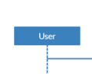

**: Uses functions, logs in and has admin privileges.**



**: Operations take place here and are sent to the screen.**

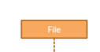

**: Data is saved and can be changed. It acts as a database.**

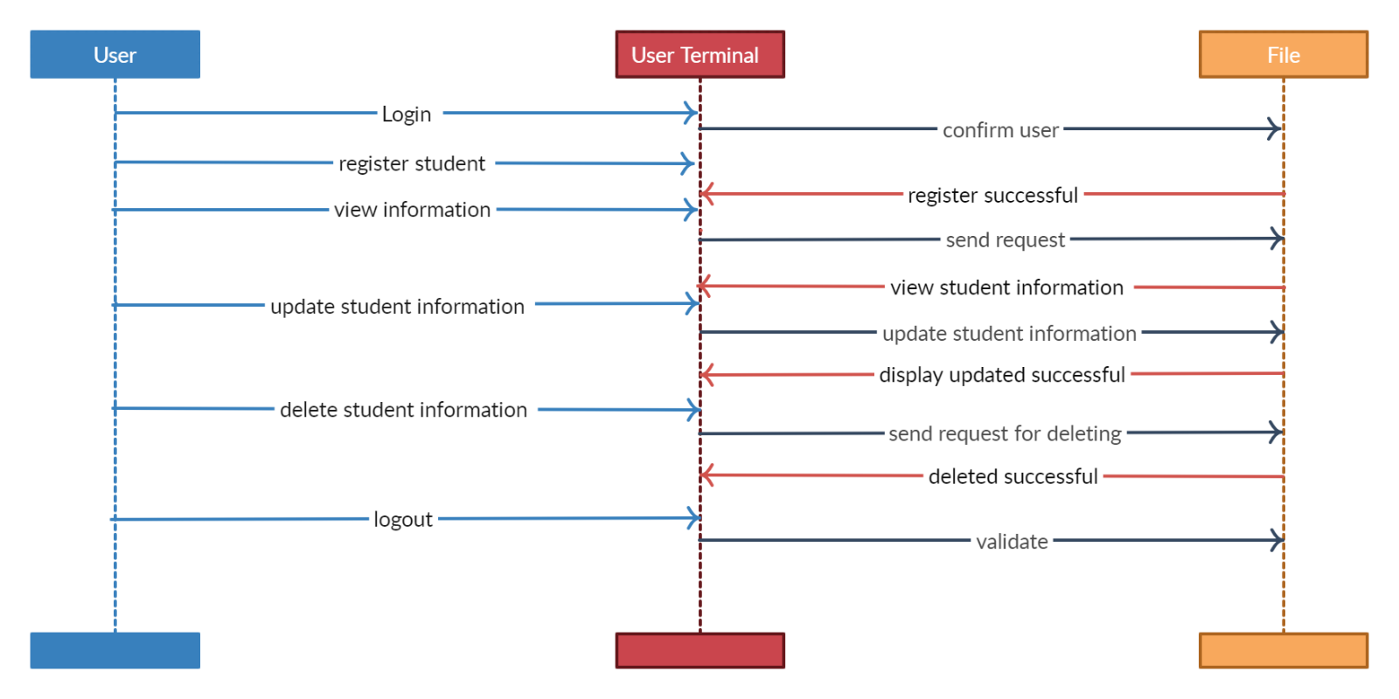

*After logging in with the administrator user name and password, multiple operations and the operation of the system are displayed in the diagram in detail and on the menu screen that you access.*

**1.2- Student Management System – Activity Diagram**

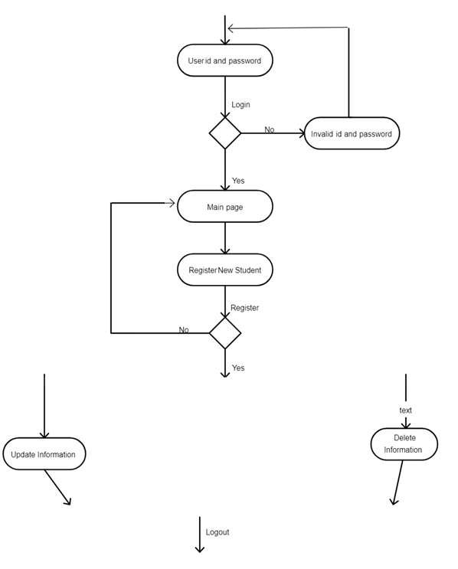

**2. System Analysis**

**2.1 Existing System: Student Information Management System**

  System Analysis is a detailed study of the various operations performed by a system and their

relationships within and outside of the system. Here the key question is- what all problems

exist in the present system? What must be done to solve the problem? Analysis begins when a

user or manager begins a study of the program using existing system.

       During analysis, data collected on the various files, decision points and transactions

handled by the present system. The commonly used tools in the system are Data Flow

Diagram, interviews, etc. Training, experience and common sense are required for collection of

relevant information needed to develop the system. The success of the system depends largely

on how clearly the problem is defined, thoroughly investigated and properly carried out

through the choice of solution. A good analysis model should provide not only the mechanisms

of problem understanding but also the frame work of the solution. Thus it should be studied

thoroughly by collecting data about the system. Then the proposed system should be analyzed

thoroughly in accordance with the needs.

In the current system we need to keep a number of records related to the student and want to

enter the details of the student and the marks manually. In this system only the teacher or the

school authority views the mark of the student and they want to enter the details of the student.

This is time consuming and has much cost.

**2.2 Proposed System : Student Information Management System**

           I will bring an update on my proposed system so students can add their details themselves.

Thus, the general expenses of school officials and teachers will be less.

Another advantage of the system is that it is very easy to edit the details of the student and

delete a student when it found unnecessary. Again, with a minor update, I will make it possible to add the student's grades to the database so that students can also see the grades whenever they want.

My proposed system has several advantages

* User friendly easy interface
* Fewer mistakes
* More Storage Capacity
* Search section
* Uncomplicated system
* Fast processing

*All the manual difficulties in managing the student details in a school or college have been rectified by implementing computerization.*

**2.3 Feasibility Analysis : Student Information Management System**

 Whatever we think need not be feasible. It is wise to think about the feasibility of any

problem we undertake. Feasibility is the study of impact, which happens in the

organization by the development of a system. The impact can be either positive or

negative. When the positives nominate the negatives, then the system is considered

feasible. Here the feasibility study can be performed in two ways such as technical

feasibility and Economical Feasibility.

***1.2.1 Technical Feasibility:***

      We can strongly says that it is technically feasible, since there will not be much

difficulty in getting required resources for the development and maintaining the

system as well. All the resources needed for the development of the software as well

as the maintenance of the same is available in the organization here we are utilizing

the resources which are available already.

***1.2.2 Economical Feasibility***

     Development of this application is highly economically feasible .The

organization needed not spend much money for the development of the system

already available. The only thing is to be done is making an environment for the

development with an effective supervision. If we are doing so, we can attain the

maximum usability of the corresponding resources .Even after the development, the

organization will not be in condition to invest more in the organization .Therefore,

the system is economically feasible

**3. Work Organization Section**

When I started my project, I had to decide what kind of system I wanted first. I looked at the previous system examples and decided what kind of project I could do in line with the knowledge I had. The right thing for me was to make a student management system. I examined all the project examples and decided how I should do it. I got ideas from some projects. I've seen different methods from some projects. And I felt like I was really improving in terms of visual awareness.

After I designed my project as a draft, I completed the code part in a short time. I got many errors. But I figured out how to solve it thanks to the internet, which provides countless resources.

I used CodeBlocks Dev C++ and Clion IDEs while doing my project.

**Conclussions and recommendations**

Student information management system lead to a better organization structure since the

information management of the students is well structured and also lead to better as well as

efficient utilization of resources.

Student Information Management System can be used by education institutes to maintain the

records of students easily. Achieving this objective is difficult using a manual system as the

information is scattered, can be redundant and collecting relevant information may be very time

consuming. All these problems are solved using this project.

My project***Student Information Management System*** was developed by ...........................

**List of used literature and other resources**

* [Stack Overflow - Where Developers Learn, Share, & Build Careers](https://stackoverflow.com/)
* [W3Schools Online Web Tutorials](https://www.w3schools.com/)
* [File handling in C - javatpoint](https://www.javatpoint.com/file-handling-in-c)
* [fopen multiple files in php - Stack Overflow](https://stackoverflow.com/questions/37778583/fopen-multiple-files-in-php)
* [C Files I/O: Opening, Reading, Writing and Closing a file (programiz.com)](https://www.programiz.com/c-programming/c-file-input-output)
* [fopen() for an existing file in write mode in C (tutorialspoint.com)](https://www.tutorialspoint.com/fopen-for-an-existing-file-in-write-mode-in-c)
* [How to create a simple C program that asks for a password and if the password is correct, access will be granted - Quora](https://www.quora.com/How-can-I-create-a-simple-C-program-that-asks-for-a-password-and-if-the-password-is-correct-access-will-be-granted-The-user-has-infinite-tries)
* [windows - C - Change text colour of single words in Console Application? - Stack Overflow](https://stackoverflow.com/questions/32622365/c-change-text-colour-of-single-words-in-console-application)
* [How do I change the full background color of the console window in C#? - Stack Overflow](https://stackoverflow.com/questions/7524057/how-do-i-change-the-full-background-color-of-the-console-window-in-c)
* [getch() function in C with Examples - GeeksforGeeks](https://www.geeksforgeeks.org/getch-function-in-c-with-examples/)
* [What is getch() in C - javatpoint](https://www.javatpoint.com/what-is-getch-in-c)